NeuMiu

Executive Summary:

A music player that sorts music by the user's choice in to multiple different types of playlists, keeps track of how many times a song has been played, allows the user to upload their own music, allows a user to assign an image to a song and rename their files, and can sort by name, genre, artist, colour, and song length.

Requirements List:

|  |  |  |
| --- | --- | --- |
| Name | Summary | Description |
| Add Music | Allows user to upload music | Users can upload different files of music, such as MP3’s, OGG’s, and more. |
| Edit Music Info | Allows user to alter the info of the song | Users can alter the metadata of an MP3 or other various formats. |
| Audio Controls | Allows changing, or pausing/playing a song. | Users can pause a song, and resume it later, or skip a song they don’t like. |
| Seek Bar | Allows jumping to certain points of a song. | Users can seek further into a song, to bypass a part of a lengthy song. |
| Volume Slider | Allows controlling how loud the output audio is. | Users can increase or decrease the output volume. |
| Create/Edit Playlists | Allows adding select tracks into a playlist that can be played. | Users can add or remove songs into playlists, or playlists themselves. |
| Time Stamping | Allows Users to place flags at certain times points | Users can place flags anywhere in a song to jump to that point in the song. Can be used to break up songs that are whole albums. |
| EQ-ing | Lets users have their own unique EQ settings | Users can mess with different EQ functions to give their music different sounds |
| Youtube - MP3 | Automatically transforms a youtube link into mp3’s | Makes adding music to the music library easy and efficient |
| Song Shuffling | Shuffles songs | Encripts songs in unique algorithms that shuffles the songs differently every time |
| Sort by Length/Title/Import Date | Allows users to sort their songs via their length, title, or the date that they were Imported on. | Users can search and sort songs by the time they were uploaded, by their title, or the length of said songs. |

Scope Exclusions:

* Will not do my laundry, make me a sandwich, or any other form of housekeeping.
* Music will need to be manually imported, it will not automatically search audio files.
* This is a music player, so it will only support audio. NO VIDEO.
* Is a single user application, not an online music service.
* Only supports common audio codecs, like: MP3, WAV, OGG, (and possibly FLAC).
* There will be no support for proprietary audio formats. (AAC, etc…), only common codecs will be supported.

User Stories:

1. Sally wants to add the newest album to her music library, but can’t. She uses NeuMiu to add all the songs she wants to and jams out.
2. ‘SomeSadBoi’ wants to edit the names of his songs, but can’t. With NeuMiu, he is able to edit the songs name, the songs genere, the songs artist, and the songs release date.
3. Sidney wants to skip multiple songs at once, and listen to the same song fifteen times. He can do this with the NeuMiu utility control panel.
4. Sean wants to make his music louder, so he pulls NueMiu up from the background and adjusts the volume with the volume slider.
5. Sage wants to organize her music into different playlists, and give them different names to tame her OCD. She downloads all her music into NeuMiu and is able to create many different playlists, as well as name them, and assign them a category or a colour.
6. Sebastian downloaded a whole album into her music library via a single song, and wants to break it up into separate songs. She loads the song in NeuMiu and time stamps where each song starts and ends, and is able to skip to each timestamp as if they were an individual song when she plays that song.
7. Seungchul wants to crank his bass so high the original song is distorted. He pulls up NeuMiu, and goes to the EQ options, and cranks bass up to 100%, and lowers treble to 0%. The song is now b=very distorted with bass.
8. Sue wants to listen to music, but is tired of her music player crashing other applications. Sue pulls up NeuMiu, opens up one of her custom playlists made up of music she downloaded, and jams out.
9. Sam wants to listen to music without being connected to the internet because he has a long plane ride ahead of them. They download NeuMiu, download their favourite songs, and is able to take musical shelter from the crying two year old for the whole fourteen hours.
10. Sara is tired of paying for all the latest jams, so she finds youtube videos of all her favourite songs, inputs the links into NeuMiu, and jams out to all her favourite songs … FOR FREE!
11. Samuel is tired of predicting what song will come next on his playlist, even on shuffle. He downloads his music into NeuMiu and listens to a songs in a different order every time.

Technical Stories:

* Add Music
  + The user is able to add their own music to the player
* Edit music info
  + Users are able to enter their own information for the songs, or edit already existing information
* Audio controls
  + Allows the user to adjust the volume, or mute it completely.
* Seek bar
  + Allows users to skip songs or repeat songs, also to jumped to certain flagged points in the song
* Volume Slider
  + Controls how loud the music is being put out, or sound is mute all together
* Create / Edit playlists
  + Users can create their own playlists, name them, and assign them to various categories.
* Time Stamping
  + This places flags at certain time points in a song that users can easily fast forward or rewind to.
* EQ
  + This allows the user to mess with the settings and make certain components of the song louder or quieter.
* Youtube - MP3
  + This will enable the user to easily add any music to their program. They will copy and paste the link, and the program will change that video into an MP3 and add it to their playlist with abilities to edit the information.
* Song shuffling
  + Songs and playlists can be shuffled by Name, Time, Artist, Genre, or
* Sorting songs by time and length
  + Songs can be sorted by the days they were released, or by how long each song is

Mock Ups:

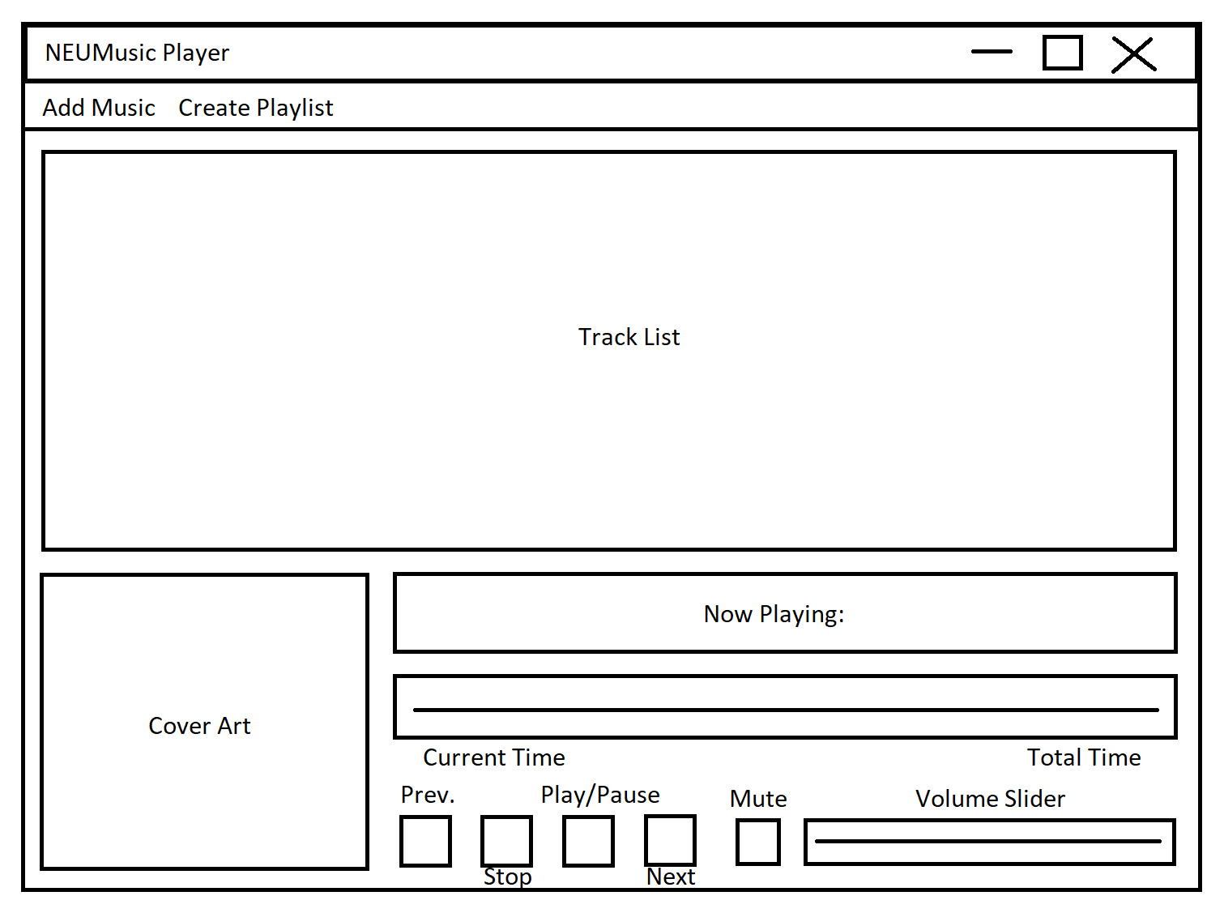

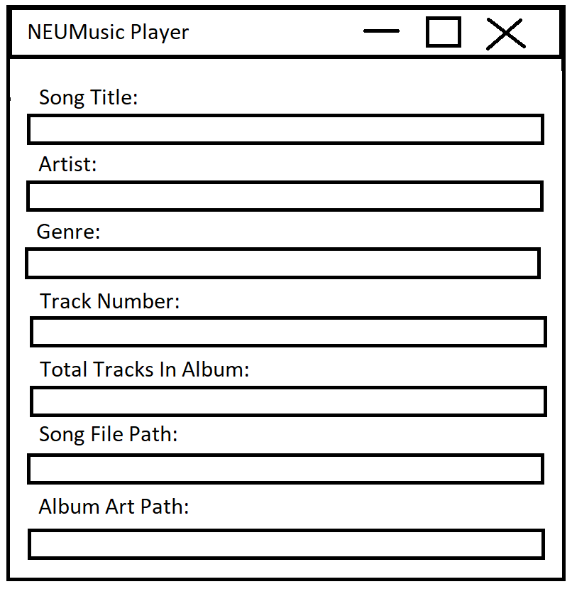

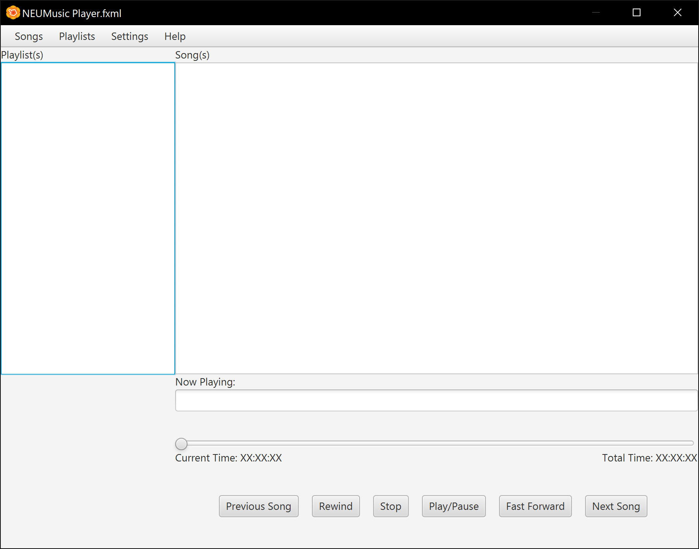

Specific Terms:

* MIDI - Musical Instrument Digital Interface
* MP3 - MPEG (Motion Picture Experts Group) Layer-3
* OGG - Jargon for Ogging
* M4A - Different form of compression for MP3’s
* WAV - Waveform Audio File
* EQ - Equalization

What people want

1. A player that works
2. Volume - loud and soft
3. Display of album art
4. Free - no adds
5. Easy to navigate
6. Library capacity
7. Device compatible
8. Share playlists - II
9. Sort songs alphabetically
10. Mood playlists (add moods to songs) - II
11. Simple user friendly design
12. EQ - I
13. Mashup music tastes (share and mix playlists)
14. Favorite songs
15. Guesses music preference? - Recommended music
16. Simple interface
17. Timer - music stops after certain amount of time
18. Easy shuffle
19. Easy way to queue music
20. Repeat option
21. Lyrics page - I
22. Data configuration
23. Download music
24. Pictures to playlists
25. Music access w/o internet
26. Music sorted by time it was released